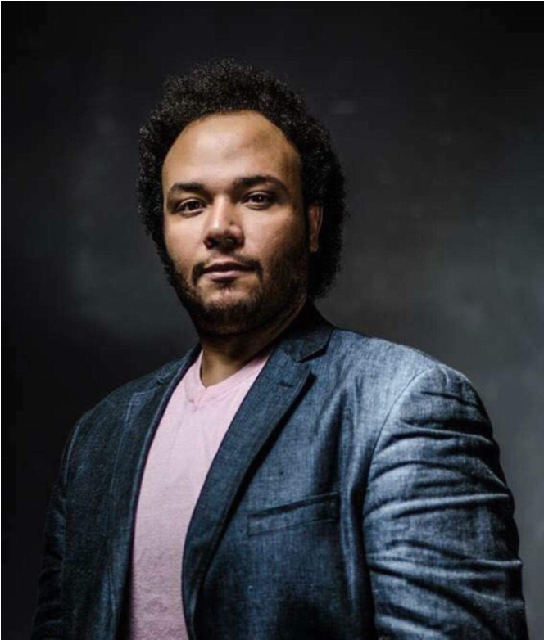
Hany Abdelzaher | TENOR

Telefon: +4369917159698
Email: mr.hanyabdelzaher@gmail.com

Opera experience

Production | Composer | Role | Place | Year
Il Trovatore | Verdi | Manrico | Cairo Opera Hause | 2022*
Aida | Verdi | Radames | Almaty National Theater | 2021
Cavalleria Rusticana | Mascagni | Turiddu | Teatro Luigi Mancinelli | 2021
Cavalleria Rusticana | Mascagni | Turiddu | Cairo Opera Hause | 2021  Canceled
Un ballo in maschera | Verdi | Riccardo | Almaty National Theater | 2020  Canceled
Don Carlo | Verdi | Don Carlo  ( Cover ) | Salzburg Osterfestspiele | 2020  Canceled
Aida | Verdi | Radames | Theater Bielefeld | 2020  Canceled
La Clemenza di Tito | Mozart | Tito | Wiener Konzerthaus | 2018
La Clemenza di Tito | Mozart | Tito | Graz Musikverein | 2018
Carmen | Bizet | Don Jose | Montenegro Operosa Festival | 2018
Idomeneo | Mozart | Idomeneo | Theater Akzent Wien | 2018
Iolanta | Tchaikovsky | Vodemon | Montenegro Operosa Festival | 2017
Gianni Schicchi | Puccini | Rinuccio | Salzburg Mozarteum | 2017
The Rape of Lucretia | Britten | Male Chorus | Salzburg Mozarteum | 2016
Carmen | Bizet | Don Jose | Salzburg Mozarteum | 2016
L’incoronazione di Poppea | Monteverdi | Nerone | Salzburg Mozarteum | 2015
Madama Butterfly | Puccini | Pinkerton | Cairo Opera Hause | 2014
La Boheme | Puccini | Rodolfo | Cairo Opera Hause | 2013
Rigoletto | Verdi | Duca | Cairo Opera Hause | 2012
L’elisir d‘Amore | Donizetti | Nemorino | Cairo Opera Hause | 2011
Die Zauberflote | Mozart | Tamino | Cairo Opera Hause | 2010

Concert experience

Production | Composer | Role | Company | Year
Verdi Gala | Verdi | Tenor Solo | Theater Orfey Moscow | 2021*  Canceled
Requiem | Verdi | Tenor Solo | Cairo Opera House | 2021*  Canceled
Carmen | Bizet | Don Josè | Hamburg Symphony Orchestra | 2019
New Year Gala |  | Solo Concert | Vienna Young Philharmonie | 2019
Werther | Massenet | Werther | Hamburg Symphonie Orchestra | 2018
Gala Concert |  | Solo Concert | Moscow Theater Orfey | 2018
Petite messe Solennelle | Rossini | Tenor solo | Cairo Symphonie Orchestra | 2017
Aida | Verdi | Radames | Salzburg Philharmonie | 2016
Requiem | Verdi | Tenor solo | Cairo Symphonie Orchestra | 2016
Messa di Gloria | Puccini | Tenor solo | Cairo Symphonie Orchestra | 2015
Stabet Mater | Dvorak | Tenor solo | Cairo Symphonie Orchestra | 2014
Beethoven Fantasy | Beethoven | Tenor solo | Cairo Symphonie Orchestra | 2013
Messe | Haydn | Tenor solo | Cairo Symphonie Orchestra | 2012
Requiem | Mozart | Tenor solo | Cairo Symphonie Orchestra | 2011

Education and Professional Training

Name | Year
Universität Mozarteum Salzburg (MA) | 2015-2017
Trinity Guildhall London (LTCL) | 2013-2014
Kairo Konservatorium (BA) | 2006-2011

Competitions

- Winner Of the 26th International Opera Singing Competition “Spazio Musica” Orvieto, Italy 2021
- Diploma from the “ Benjamino Gigli” International Opera Singing Competition Roma, Italy 2018

