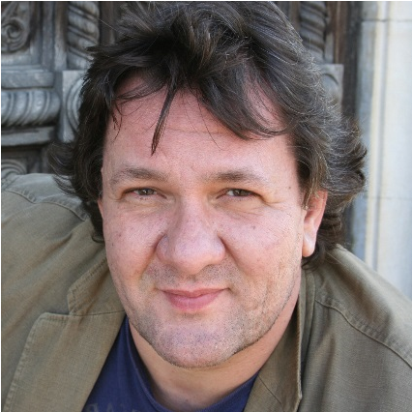 | Giorgi Kirof  Bass  DOB: June, 1970  Languages: French, Italian, Russian, English, German  Е-mail: giorgi.kirof@gmail.com  Mobile: +359 884 3144 32  +359 889 6663 88  Website: http://kirofbass.jimdo.com/  College: French College  University: Rome, Italy, Academy of Arts  Musical Instrument: Classical guitar  International Music Award:  Artist for 2019, Foundation Nicola Ghiuselev
Kirof has sung for:
Metropolitan Opera, New York – Timur (Turandot)
Savonlinna Opera Festival – Varlaam (Boris Godunov)
Teatro Real Madrid – Timur (Turandot)
arte TV – Il Commendatore (Don Giovanni)
Spanish TV - Zaccaria (Nabucco)
Season 2016/2017
Padre Guardiano (La Forza del Destino) - Tampere Hall
Sarastro (Die Zauberfloete) - Immling Festival, Germany
Zaccaria (Nabucco) c. - Metropolitan Opera, New York
Gremin (Eugeni Onegin) c. - Metropolitan Opera, New York
Season 2017/2018
Timur (Turandot) - Metropolitan Opera, New York
Verdi Requiem Bass c. - Metropolitan Opera, New York
Timur (Turandot) – Sofia National Opera
Gremin (Eugene Onegin) – Sofia National Opera
Ramfis (Aida) – Sofia National Opera
Zio Bonzo (Madama Butterfly) – Savonlinna Opera Festival
Season 2018/2019
Ramfis (Aida) c. – Metropolitan Opera, New York
Old Hebrew (Samson et Dalila) c. – Metropolitan Opera, New York
Timur (Turandot) – Teatro Real Madrid
Season 2019/2020
Sparafucile (Rigoletto) – Sofia National Opera and Ballet
Verdi Requiem – Aarhus symphony
Season 2021/2022
Shostakovich, Symphony 14 – NFM Wratislavia Cantans
Verdi Requiem – Tampere Hall
Zaccaria – Opera de Massy
Beethoven 9th – Tampere Hall
Ramfis – Braunschweig Opera Festival
IL Re - Braunschweig Opera Festival

Roles on Stage:

G. Verdi:
Zaccaria (2002, 2003, 2008, 2012, 2013, 2014, 2016, 2017, 2022)
Ferrando (2004; 2005)
Sparafucile (2001, 2002, 2003, 2004, 2014, 2019)
Ramfis (2003, 2005, 2006, 2008, 2013, 2018, 2019, 2022)
IL Re (2004, 2011, 2014, 2022)
Grande Inquisitore (2002, 2003, 2008)
Fiesco (2008, 2009, 2010, 2019)
Padre Guadiano (2016)
Requiem (2017, 2019, 2021, 2022)

R. Wagner:
Fafner (2010; 2011; 2015)

W.A. Mozart:
Osmin (2000; 2001)
Sarastro (2002, 2016, 2019)
Il Commendatore (2008; 2009; 2010, 2019)

G. Rossini:
Don Basilio (2001; 2002; 2006; 2010)

G. Puccini:
Timur (2006; 2010; 2014, 2017, 2018, 2019)
Zio Bonzo (2007; 2012, 2018)
Angelotti (2009)

V. Bellini:
Oroveso (2007)

G. Donizetti:
Sir Talbot (2011)

Borodin:
Kontchaak (2010)

P. Tchaikovski:
Gremin (2007; 2008, 2017, 2018)

M. Mussorgsky:
Varlaam (2015)
Songs and Dances of Death (2018)

C. Saint-Saëns:
Old Hebrew (2018)

D. Shostakovich:
Symphony 14 (2021)

Ludwig van Beethoven:
Symphony 9 (2022)

Biography

GIORGI KIROF

The Bulgarian Bass Giorgi Kirof has sung on stages such as MetropolitanOperaNY (Timur/Turandot), Großes Festspielhaus in Salzburg(Il Grande Inquisitore /Don Carlo), On Savonlinna Opéra Festival (Varlaam/Boris Godunov) ,with Münich Philharmonie in Gasteig (Sir Talbot/Maria Stuarda), and many others in USA, Spain, France, Austria, Italy, Germany, Netherlands and Japan.
Giorgi Kirof studied voice at the Academy of Arts, Rome, Italy. On the stage of Sofia National Opera he has sung main bass roles such as Zaccaria/Nabucco, Fiesco/Simon Boccanegra, Timur/Turandot, Don Basilio/Barbiere di Siviglia as well as Osmin/Die Entfuehrung aus dem Serail and Fafner/Rheingold.
In season 2021/22 Mr. Kirof made his house debut in NFM Wratislavia Cantans (Shostakovich, Symphony 14), sang in Tampere Hall (Verdi/Requiem) and later same season once again in Tampere Hall (Beethoven 9th ). With his crown role (Zaccaria /Nabucco) he appear in Opera de Massy, Paris. In summer Opera Festival in Braunschweig in their open air production of Aida he could have been heard as Ramfis as well as the The King.
Two roles of Mr. Kirof have been televised—Il Commendatore (Don Giovanni) for ARTE TV and Zaccaria (Nabucco) for Spanish TV. ﻿Mr. Kirof received an international prize -musician for 2019 from the foundation on the name of world famous bass Nicola Ghiuselev. ﻿"“... priceless for me, most of all because is on the name of my Maestro...” (Kirof).
Among Singers with whom G.Kirof has collaborated are— Placido Domingo, Anna Netrebko, Matti Salminen, Krassimira Stoyanova, Iréne Theorin and Gregory Kunde. Kirof performed Under the baton of conductors, such as - James Levine, Carlo Rizzi, Ruslan Raichev, Sir Mark Elder and Leif Segerstam.

