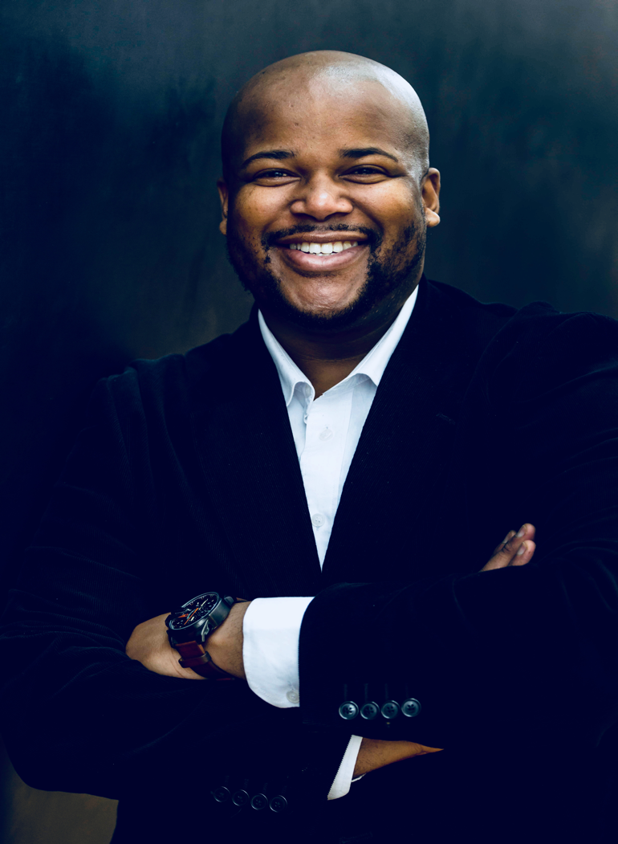

BIOGRAPHY / CV

Siyabulela Ntlale – (Classical) Singer/Performer
Place of Birth: Port Elizabeth
Date of Birth:19 August , 1985
Nationality: South African
E-mail address: siyabulelantlale@gmail.com
Mobile number: +27 781916242/ +49 17665765959

Siyabulela Ntlale (Baritone) , in 2014 was awarded 2nd place in the finals of the 33rd International Hans Gabor Belvedere Singing Competition and in 2013 was the first recipient of the Gobbato-Qavane Operatic Award for outstanding performances in advanced studies and also in 2014 became 3rd student to receive the Realto/Olitalia bursary. A post graduate from the South African College of Music (SACM) at the University of Cape Town (UCT) under the direction of Professor Kamal Khan, Siyabulela was born in Port Elizabeth and grew up singing the local Choral Choir. The Matthews Singers, under the baton of Mzwandile Christopher Matthews. In 2006 he worked with Albert Horn of Cape Town Opera and it's Vocal Ensemble and 2009 began to study at the SA College of Music at UCT with Patrick Tikolo, which he changed to George Stevens in 2014.

Siyabulela has performed in many UCT-SACM and Cape Town Opera (CTO) productions that include; IlViaggio A Reims- Barone di trombonock (G.Rossini), La Boheme- Schaunard (G. Puccini), Don Giovanni-Leporello (WA.Mozart), Le Contes d'Hoffmann- Dapertutto (J.Offenbach), Il Barbiere di Siviglia- Don Bartolo (G.Rossini) Le Nozze di Figaro- Don Bartolo (WA Mozart),The Rake's Progress- Sailor (I.Stravinsky), The Dead Man Walking- 1st Prison Guard (J.Heggie), Simone Boccanegra- Paolo (Scenes, G.Verdi), Falstaff- Falstaff ( Fuge Scene,G.Verdi), Le Convenienze ed Incinvenienze Teatrali- Mamma Agata (G.Donizetti) produced by the Richard Wagner Society in 2012. Siyabulela was selected as a soloist in the 2012 and 2014 Arts Cape/Cape Town Philharmonic Orchestra Youth Music Festival.

International debutant with Theater Erfurt (Germany) with role of “Rigoletto” by Giuseppe Verdi which won an Audience prize as the best production in the season of 2014/2015 and also with the Deutsche Oper Am Rhein- Düsseldorf in Germany in the 2015/2016 season.

Since the 2014/2015 season Siyabulela has joined Theater Erfurt as Baritone Soloist… with the following roles so far:

Don Giovanni “ Don Giovanni “ ( W. Mozart )
• Johannes Gutenberg “Johannes Gutenberg” (D. Kirchner)
• Cesare Angelotti “Tosca” ( G. Puccini)

• Hermann Ortel “Meistersinger” ( R. Wagner )
• Don Afonso “ Cosi fan Tutte” ( W. Mozart)
• Hercules “Hercules” ( G.Handel)
• 2. Hanwerksbursch “Wozzeck” (A. Berg)
• Mercutio “Romeo and Juliette” ( C. Gounod)
- Rigoletto “Rigoletto” (G. Verdi) with DEUTSCHE OPER AM RHEIN
- Giulietta e Romeo “ Tebaldo “ ( R. Zandonai )
- Zauberflöte “ 1st Priest “ ( W. Mozart )
- Hänsel und Gretel “ Peter “ ( E. Humperdinck )
- Médée “ Crèon “ ( L. Cherubini )
- Es liegt in der Luft “ Jack Smith “ ( M. Spoliansky )

For the 2018/2019 season:

- Escamilio “ Carmen “ ( G. Bizet )
- Priest- Sprecher “ Zauberflöte “ ( W. Mozart )
- Blechmann “ Zauber von Oz “ ( V. Pierangelo )
- 1st Guard “ Dead Man Walking “ ( J. Heggie )
- Jack Smith “ Es liegt in der Luft “ ( M. Spoliansky )
- Amonasro “ Aida “ ( G. Verdi )
- Carmina Burana ( Carl Orff )

For the 2019/2020 season:
- Don Pasquale “ Don Pasquale “ ( G. Donizetti )
- Hänsel und Gretel “ Peter “ ( E. Humperdinck )
- Lohengrin “ Heerufer “ ( R. Wagner )
- Le Nozze di Figaro “ Il Conte “ ( W. A. Mozart )

Domstuffen Sommer- Festspiele 2020

- Nabucco “ Nabucco “ ( G. Verdi )

